A000-US-IL-Gorget-Slate-900 CE

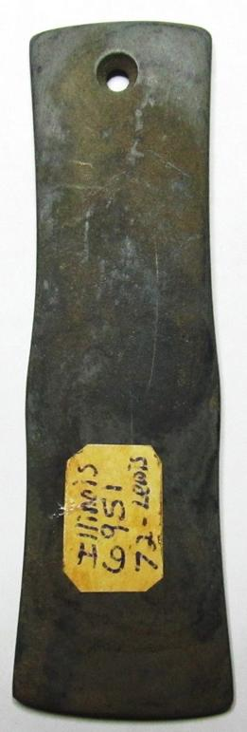 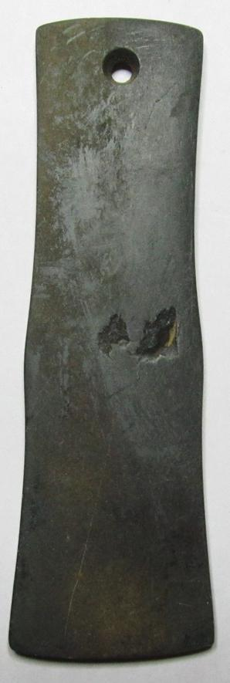

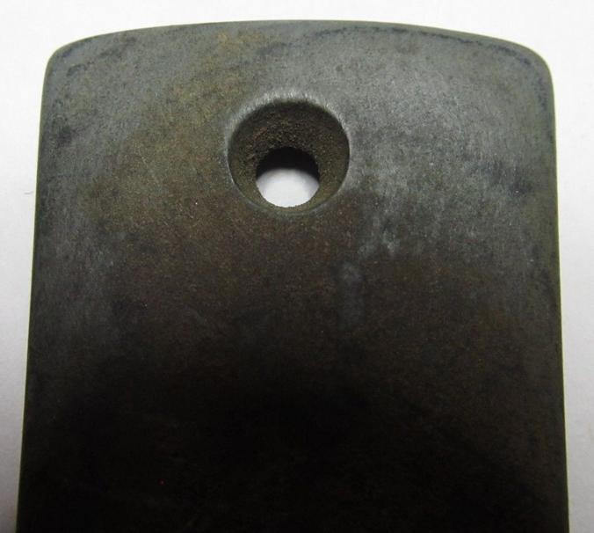

US-IL-Gorget-Slate-900 CE

Case No.: 12

**Accession No.**

**Formal Label:** US-IL-Gorget-Slate-900 CE

**Display Description:**

**LC Classification:**

**Date or Time Horizon:**

**Geographical Area:**

**Map:**

**GPS coordinates:**

**Cultural Affiliation:**

**Media:**

**Dimensions:**

**Weight:**

**Condition:**

**Provenance:**

**Discussion:**

**References:**

